**CHAPTER 1**

**INTRODUCTION**

**1.1 OBJECTIVES:**

People commonly use their facial expressions to express their moods/emotions. Quotes has always had the ability to change a person's mood. Capturing and identifying a person's mood/emotion and display appropriate quotes to match that emotion can help to soothe the user's mind and provide a pleasurable effect. This model aims to capture the mood/emotion of the user through their facial expressions. Through the webcam interface available on computing systems, a quote is meant to record human expression and identification of point face landmarks to analyse the emotion/mood of the user at that time. Facial expression recognition has been the best type of expression analysis known to humanity since ancient times. The most effective approach for people to assess or draw conclusions about another's emotion, feeling, or thoughts. A person is attempting to convey their feelings through facial expressions.

**1.2 MODULE DESCRIPTION:**

The entire project mainly consists of 2 modules, which are

1. TRAINING module

2. TESTING module

**TRAINING MODULE:**

A training module is a segment of an overall eLearning course that focuses on a specific topic or objective. Think of it like a chapter of a book. Each training module acts as a step in a learner's journey, each time edging closer to completing the overall course.

**TESTING MODULE:**

Module testing is defined as a software testing type, which checks individual subprograms, subroutines, classes, or procedures in a program. Instead of testing whole software program at once, module testing recommends testing the smaller building blocks of the program. Module testing is largely a white box oriented.

**CHAPTER 2**

**SYSTEM STUDY AND SPECIFICATION**

* 1. **PROBLEM STATEMENT**

Despite the availability of software to extract data regarding a person’s sentiment on a specific product or service, organizations and other data workers still face issues regarding the data extraction.

**2.2 MOTIVATION**

**Human perspective:**

* Face analysis is very easy for humans! -- Can't be difficult!?
* Understanding the human visual system, might help to understand the human brain.

**Computer Vision:**

* Biometry: Face Recognition, Face Verification.
* Man-Machine Interface: Emotion recognition, gaze analysis, attention control.

**Video coding:**

* MPEG-4 standard for face and emotion coding

**Psychology:**

* How do humans memorize faces?
* Do we judge personal attributes from face images?

**Face recognition from different modalities:**

* From single image.
* From two or more image, from video.

**Face recognition covers different tasks:**

* Face verification
* Face identification
* Expression and emotion recognition

**2.3 EXISTING SYSTEM**

Aesthetic analysis (or opinion mining) is a natural language processing (NLP) technique used to determine whether data is SAD, HAPPY, NEUTRAL, FEAR, ANGRY, SURPRISE. Sentiment analysis is often performed on textual data to help businesses monitor brand and product sentiment in customer feedback, and understand customer needs

**2.4 DRAWBACKS OF EXISTING SYSTEM**

* Sentiment Neutral Statements with Negative or Positive Reputational Impact.
* Incorrectly Targeted Sentiment.
* Review Language is Dissimilar to social media and News Language.

**2.5 PROPOSED SYSTEM**

As projects with emotional intelligence has already exits, now we have come up with new features such as live face detection and according to their emotions a Quotes to the users. Since there is no such kind of features available in the existing model, we have added extra comfort for the user.

**2.6 FEATURES OF THE PROPOSED SYSTEM**

Aesthetic analysis is a type of data analytics that deals specifically with text that expresses various forms of emotions - from love to hate. All the data-driven does not just mean data-gathering but truly understanding it as well. Consumers often touch on many aspects of a product or service. Complaints or praise for price, quality, or ease-of-use can all be mentioned in one comment. Aesthetic analysis at the aspect level first determines which categories are being mentioned, and then calculates the sentiment for each of those categories.

**FACE DETECTION USING A WEBCAM**

The next step would be processing the captured image and determine the user’s emotion. Classify the user’s expression into the following categories

1. HAPPY
2. NEUTRAL
3. SAD
4. ANGRY
5. FEARFUL
6. SURPRISED

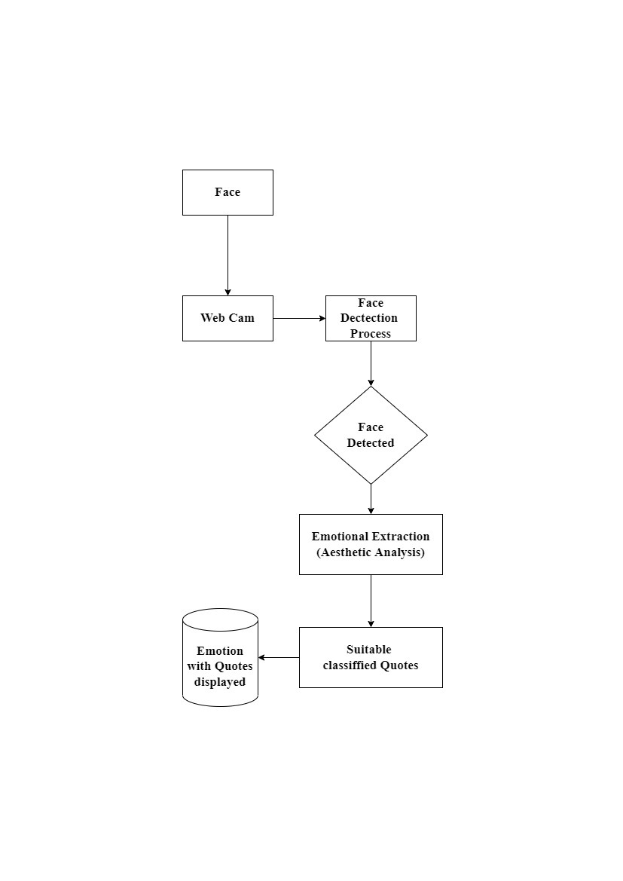

**Fig.2.1. Architecture of Mood Based Quotes Recommendation System**

**2.7 SOFTWARE REQUIREMENTS**

* PROCESSOR: Intel core i3
* CAPACITY:80 GB
* RAM:4GB

**2.8 HARDWARE REQUIREMENTS**

* OPERATING SYSTEM: Windows 10

**CHAPTER 3**

**SYSTEM DESIGN AND DEVELOPMENT**

**3.1 FLOWCHART**

The process starts by detecting

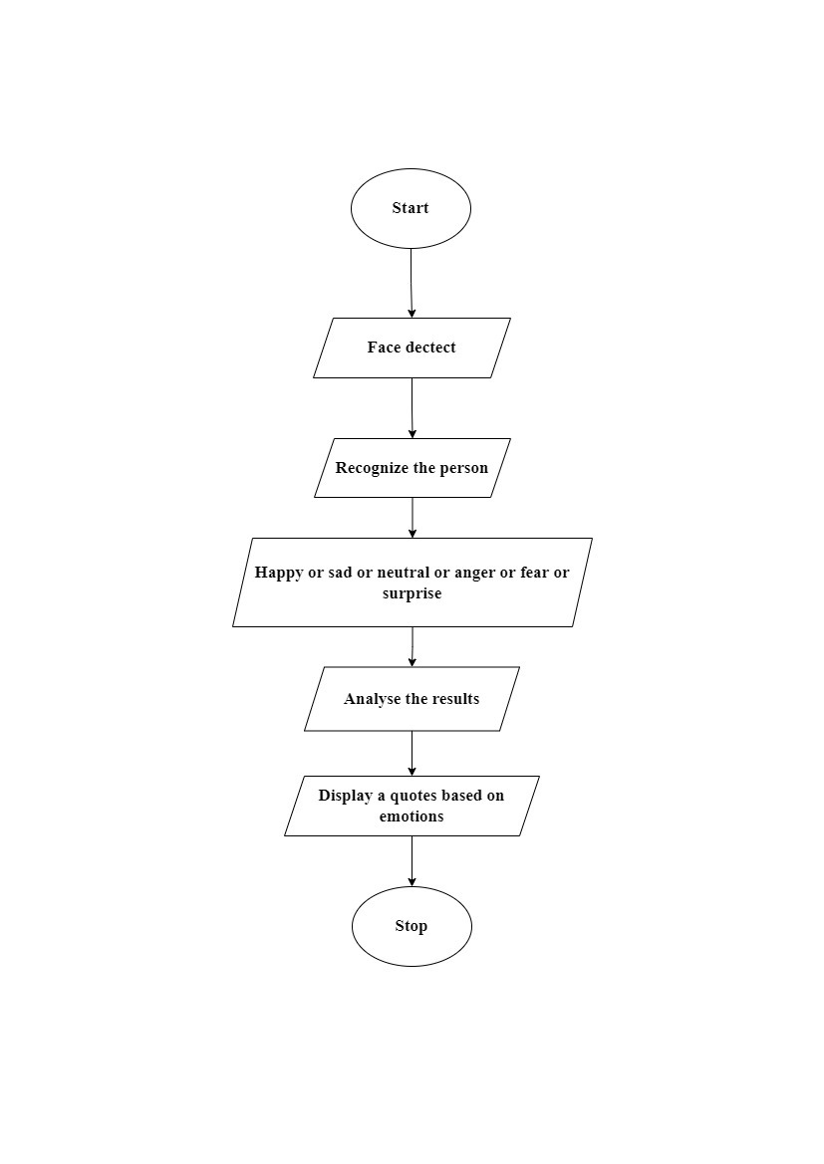

**Fig.3.1. FLOW CHART**

The process starts by detecting the faces. It detects the emotion of a person based on their facial expressions such as happy, sad, surprise, anger, fear, neutral etc. According to the analysed facial result related quotes will be displayed on the screen.

**3.2 SYSTEM DEVELOPMENT**

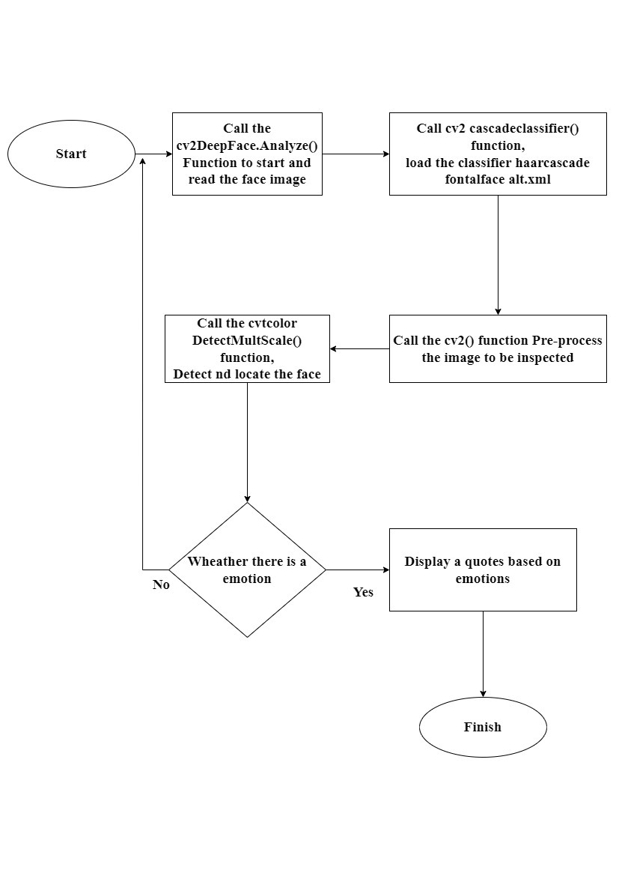**FIG.3.2. System Development**

The function called CV2 Deepface. Analyze() is called to start and read the face image than CV2 cascadeclassifier() function is called to load the classifier. After loading the classifier, the image has been inspected by CV2() function. The CVt color detectMultiScale() function detect and locate the face. Once there is an emotion has been detected the emotion will be displayed or else it will be redirected to the beginning of the process.

**CHAPTER 4**

**CONCLUSION AND FUTURE ENHANCEMENT**

* 1. **CONCLUSION**

In this mini project, we presented a model for recommending quotes on the basis of facial expression mood detection and recommending appropriate quotes to the user. This project proposes designing and developing a quotes recommendation system on the basis of emotion captured through face recognition. Quotes has the ability to heal any type of stress or anxiety. Recent advancements suggest that establishing an emotion-based motivational quotes recommendation system has a lot of potential. As a result, the suggested system includes a face-based emotion identification system that can detect emotions and display a quote based on those emotions.

**CHAPTER 5**

**ANNEXURES**​

* 1. **SCREENSHOTS**

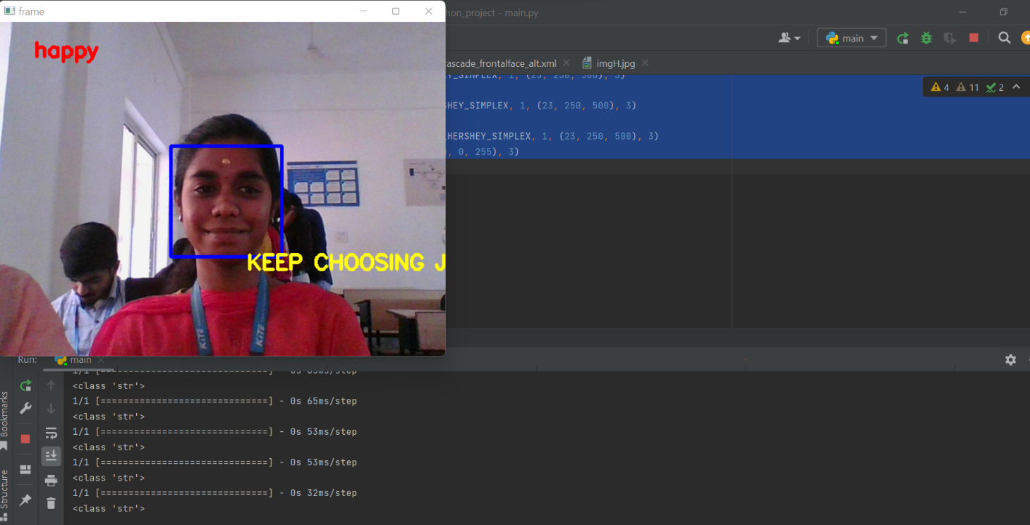

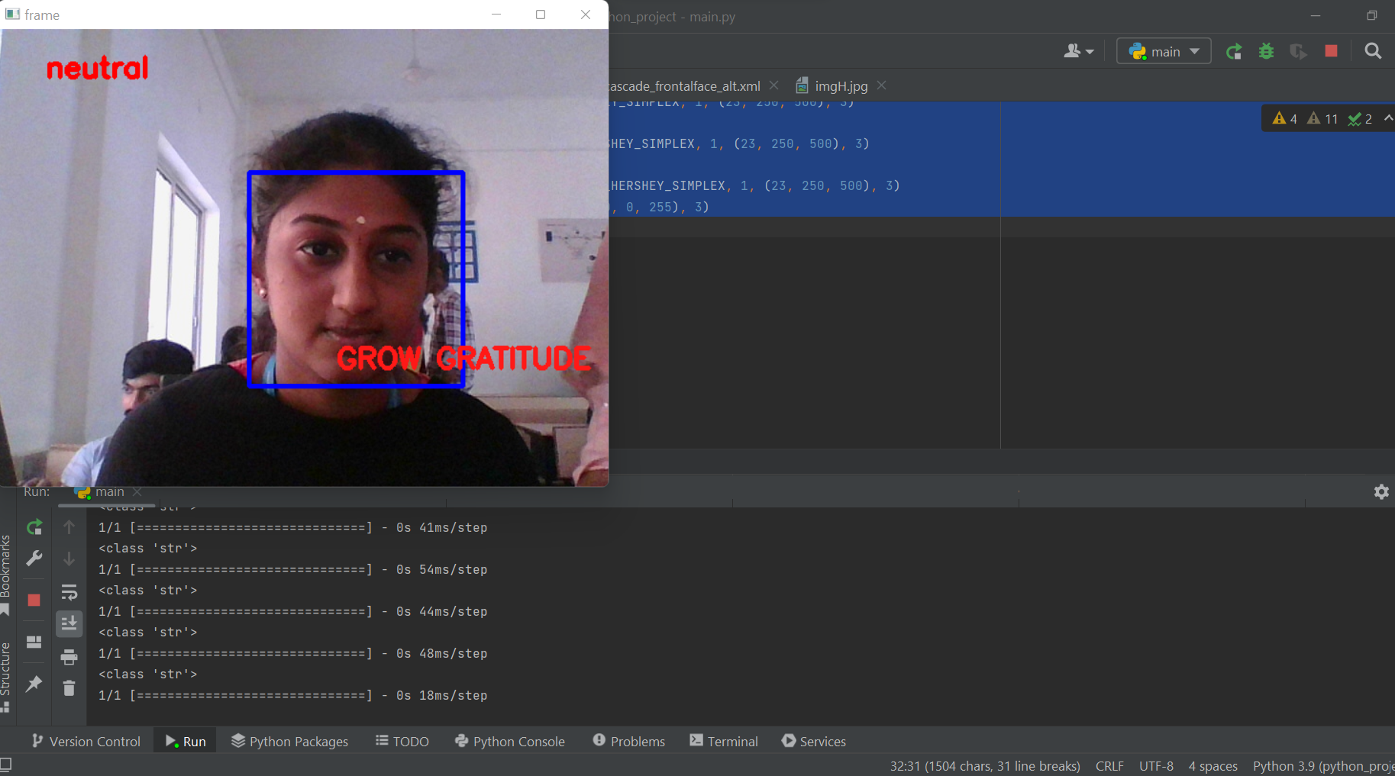

* 1. **SOURCE CODE**

import cv2

from deepface import DeepFace

import numpy as np

face_cascade= cv2.CascadeClassifier('D:/python_project/haarcascade_frontalface_alt.xml')

cap = cv2.VideoCapture(0)

while True:

ret, frame = cap.read()

result = DeepFace.analyze(img_path=frame, actions=['emotion'], enforce_detection=False)

gray = cv2.cvtColor(frame, cv2.COLOR_BGR2GRAY)

faces = face_cascade.detectMultiScale(gray, 1.1, 4)

for (x, y, w, h) in faces:

cv2.rectangle(frame, (x, y), (x + w, y + h), (255, 0, 0), 3)

emotion = result["dominant_emotion"]

print(type(emotion));

txt = emotion;

if(txt=='sad'):

cv2.putText(frame, "SEE THE GOOD!", (300, 300), cv2.FONT_HERSHEY_SIMPLEX, 1, (255, 255, 255), 3)

elif(txt=='neutral'):

cv2.putText(frame, 'GROW GRATITUDE', (355, 355), cv2.FONT_HERSHEY_SIMPLEX, 1, (23, 25, 255), 3)

elif (txt == 'happy'):

cv2.putText(frame, 'KEEP CHOOSING JOY', (355, 355), cv2.FONT_HERSHEY_SIMPLEX, 1, (23, 250, 500), 3)

elif (txt == 'angry'):

cv2.putText(frame, 'STAY SILENT', (355, 355), cv2.FONT_HERSHEY_SIMPLEX, 1, (23, 250, 500), 3)

elif (txt == 'fear'):

cv2.putText(frame, 'FOCUS AND WIN', (350, 350), cv2.FONT_HERSHEY_SIMPLEX, 1, (23, 250, 500), 3)

elif (txt == 'surprise'):

cv2.putText(frame, 'EVERYTHING COUNTS', (350, 350), cv2.FONT_HERSHEY_SIMPLEX, 1, (23, 250, 500), 3)

cv2.putText(frame, txt, (50, 50), cv2.FONT_HERSHEY_SIMPLEX, 1, (0, 0, 255), 3)

cv2.imshow('frame', frame)

**5.3 REFERENCES**

1. M.Rambocas, and J. Gama, “MarketingResearch:TheRoleof SentimentAnalysis”. The 5th SNA-KDD Workshop’11. Universityof Porto, 2013.
2. D. Boyd, S. Golder, & G. Lotan, “Tweet, tweet, retweet: Conversational aspects of retweeting on twitter,” System Sciences (HICSS), 2010 …. Retrieved from <http://ieeexplore.ieee.org/xpls/abs_all.jsp?arnumber=5428313>
3. A. Sweigart, “Invent your own computer games with Python. 2nd edition, 2012. Retrieved from <http://inventwithpython.com/>
4. V. Nareyko, “Why python is perfect for startups,” Retrieved 01 10, 2014 from: <http://opensource.com/business/13/12/why-python-perfect-startups>
5. A. Hawkins, “There is more to becoming a thought leader than giving yourself the title”. Retrieved 10 18, 2013. from: <http://www.thesocialmediashow.co.uk/author/admin/>
6. T. Carpenter, and T. Way, “Tracking Sentiment Analysis through Twitter,”. ACM computer survey. Villanova:VillanovaUniversity, 2010.